5-4-3-2-1
After reading a page or paragraph in your textbook complete the chart below to help you sum up what you have learned.
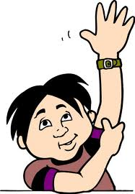 | Keywords from the pages  1.  2.  3.  4.  5.
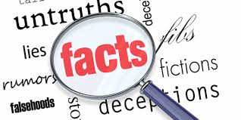 | Facts related to the main topic  1.  2.  3.  4.
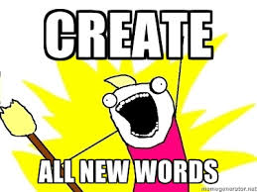 | New words  1.  2.  3.
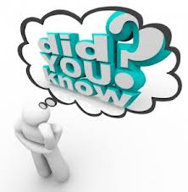 | Facts you already know  1.  2.
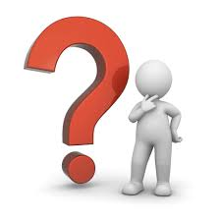 | Questions you still have  1.

